Configuring CMAKE with MPICC

This tutorial shows how to run friend’s MPI program written in C.

- Import program to create initial CmakeList.txt file. In Clion File→Import project… → select folder with project → choose needed files to include → Press ok
- Paste and of course modify for your needs this code into CmakeList.txt:

cmake_minimum_required(VERSION 3.5)
project(source)
set(CMAKE_CXX_STANDARD 11)
find_package(MPI REQUIRED)
include_directories(${MPI_INCLUDE_PATH})
set(SOURCE_FILES
CAssigmentHPC.c
SolverParallel.c
SolverParallel.h
SolverSingle.c
SolverSingle.h
Utility.c
Utility.h)
add_executable(source ${SOURCE_FILES})
#THIS LINE IS CRUCIAL FOR BUILD!!! m parameter is equivalent of -lm flaf
target_link_libraries(source ${MPI_LIBRARIES} m)
if(MPI_COMPILE_FLAGS)
set_target_properties(source PROPERTIES
COMPILE_FLAGS "${MPI_COMPILE_FLAGS}")
endif()
if(MPI_LINK_FLAGS)
set_target_properties(source PROPERTIES
LINK_FLAGS "${MPI_LINK_FLAGS}")
endif()
#[[
find_package(MPI REQUIRED)
include_directories(${MPI_INCLUDE_PATH})
SET(CMAKE_C_COMPILER mpicc )
#set(CMAKE_C_FLAGS "${CMAKE_C_FLAGS} -lm")
set(CMAKE_C_FLAGS "-lm")
set(CMAKE_C_FLAGS_DEBUG "-lm")
set(MPI_COMPILE_FLAGS "-lm")
SET(CMAKE_CXX_COMPILER mpicxx)
set(MPI_C_COMPILER mpicc)
#set(CMAKE_C_COMPILE_FLAGS "${CMAKE_C_COMPILE_FLAGS} ${MPI_COMPILE_FLAGS} -lm -std=c99")
#set(CMAKE_C_LINK_FLAGS ${CMAKE_C_LINK_FLAGS} "${MPI_C_LINK_FLAGS} -lm -std=c99" )
]]
#set(CMAKE_C_FLAGS "${CMAKE_C_FLAGS} -lm -std=c99")
#set(CMAKE_CXX_FLAGS "-std=c99 -Wall -lm")
#set(CMAKE_C_FLAGS "-std=c99 -Wall -lm")
#set(CMAKE_CXX_LINK_FLAGS ${CMAKE_CXX_LINK_FLAGS} ${MPI_LINK_FLAGS})
#SET( CMAKE_EXE_LINKER_FLAGS "${CMAKE_EXE_LINKER_FLAGS} -o" )

The most important line is:
target_link_libraries(source ${MPI_LIBRARIES} m)

For some reason m is equivalent to parameter -lm

So now built by CLion program is equivalent to following command:
mpicc CAssigmentHPC.c SolverSingle.c SolverParallel.c Utility.c -lm

-std=c99 is no needed (maybe it is implicit)

To Execute program

- Click on button next to build. It could contains Build all text or project name.

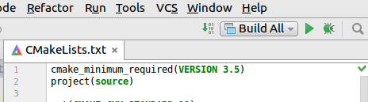

- Go to Edit Configurations and in Executable choose mpirun location in my case it was in /usr/bin/mpirun.

- In Program agguments: type arguemnts for program and file to execute e.g.
-np 2 /home/wik/Pulpit/source/source

WARNING!
Do not choose path with spaces in folder names - mpirun runed by CLion is not able to interpret that path correctly. For instance following one:
-np 2 /home/wik/Pulpit/Dokumety Moje/V rok/Cranfield/High Performance Technical Computing/source1/cmake-build-debug/source1
DOESN’T WORK!

- It should looks similar to the picture below:

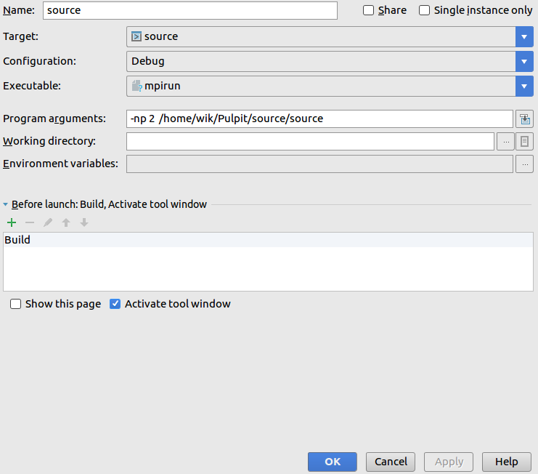

THATS ALL! But it does’t work in 100%. Compiling is ok, but there is problem with executing program.

Useful pages in order of importance (in red are highlighted the most important sites in my case):

- http://stackoverflow.com/questions/34625627/adding-math-library-with-cmake
- http://stackoverflow.com/questions/31272473/mpi-change-number-of-processors-in-cmakelists
- https://cmake.org/pipermail/cmake/2011-June/045037.html
- https://www.jetbrains.com/help/clion/2016.3/quick-cmake-tutorial.html
- http://stackoverflow.com/questions/31272473/mpi-change-number-of-processors-in-cmakelists
- https://cmake.org/pipermail/cmake/2011-July/045297.html

